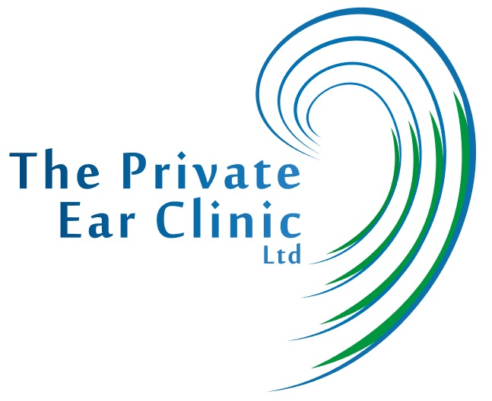
The Private Ear Clinic LTD Compliance with the UK Modern Slavery Act 2016

The Private Ear Clinic Limited is devoted to ensuring and maintaining high social, ethical and environmental standards within its business and throughout its chain of suppliers. We are dedicated to working directly with our suppliers to guarantee our standards are continuously improving and commit to comply with all legislation required.
According to the Global Slavery Index, modern slavery affects some 45.8 million people around the world. This practice can take many forms, such as forced labour, human trafficking, child labour or undignified working conditions. The Private Ear Clinic Ltd does not tolerate or accept any form of modern slavery within its operations or in its supply chain. Although we are a small UK company we take our responsibility to combat Slavery and human trafficking very highly and if we were to receive any dispute against this, we would take that very seriously.
A good reputation and compliance with applicable laws are major factors that help determine a company's success and this is something we continually strive for. It is equally important to make stringent demands on business partners and suppliers, so that they also take social responsibility seriously in their supply chain and wider operations.

Ethical Trading Policy

In order to achieve this, The Private Ear Clinic Ltd has developed the Ethical Trading Policy based on the internationally acknowledged ETI base code.

- Employment is freely chosen

- Working conditions are safe and hygienic

- Child labour shall not be used

- Living wages are paid

- Working hours are not excessive and regular fair breaks are included

- No discrimination is practised

- Regular employment opportunities are provided

- No harsh or inhumane treatment is allowed

- Bribery and Corruption is forbidden

- Conflicts of Interest are dealt with fairly

- Confidentiality is always adhered to

